**Habit tracker React app**

**Problem statement**

Create a habit tracker app, where we can define habits and track them. Create a react app.

**Instructions**

* You are **ALLOWED** to style the app any way you like, you can use any CSS framework if you want.
* You are **ALLOWED** to google and read how to approach the problem.
* **DO NOT** copy and paste code from the internet.
* **DO NOT** cheat with other students. ***REMEMBER:*** *These tests are for YOU so that you can learn something new. Cheating won’t help. It’s better to not submit the solution than to cheat and submit. PS: There will be a plagiarism check and when found cheating, you won’t be allowed to give future tests.*
* Once you have finished with the test, make a video recording your computer screen (via phone or a software like OBS/screencastify etc) and **explaining how you have approached the problem** *IN CODE* **and showing ALL THE FEATURES OF the final product**. The video can be **UPTO 5 mins** long. ***Please don’t record videos longer than that.***
* **Upload** the code on github as well, you might not host it ***SO MAKE SURE VIDEO IS PERFECT*** (you MIGHT need to host it somewhere I will share the steps if hosting would be required).
* Once you have recorded the video, upload it on youtube (unlisted or whatever), drive or wherever you want to upload it. ***If no video is submitted, the solution will be rejected.***

**Features *(No need for extra features, just make the listed features)***

* Add multiple habits to track like reading a book, going to the gym etc
* Track each habit everyday. These are the 3 statuses of a habit:
  + Done - Mark the habit as done for a day
  + Not done - Mark the habit as not done for a day
  + None - User did not take any action on a habit for a day
* A view to show all current habits. Here give an add button where you can add a new habit to track. The image is just an example, you can structure/design however you want, showing the counts etc is not mandatory

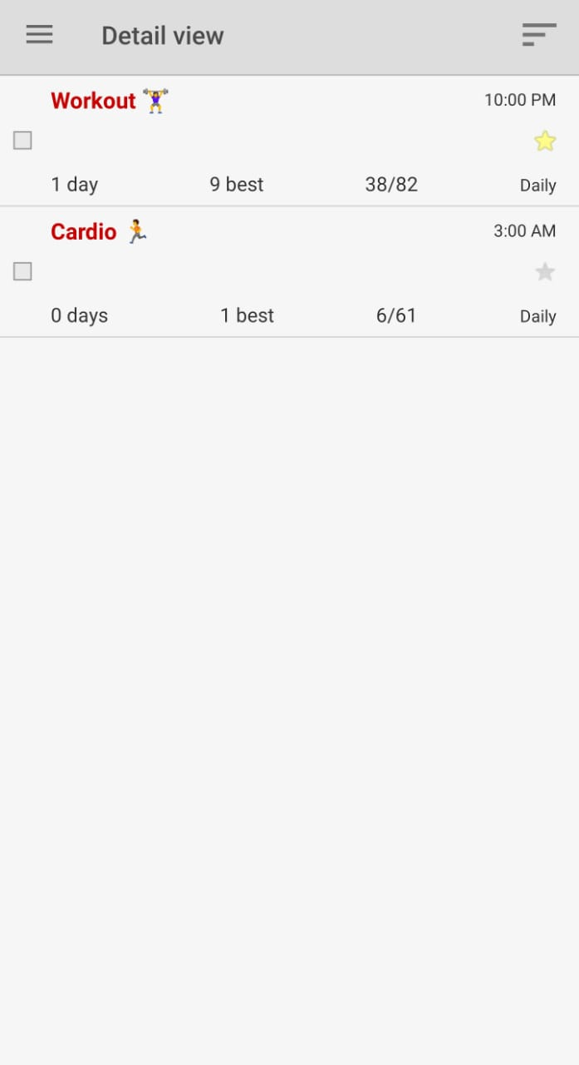

* A view to display 7 days of each habit
  + Show today where user can mark todays habit
  + And show the previous 6 days and the status of that habit for each day
  + A user can toggle between the three (above mentioned) statuses of a habit i.e. I can change today’s status as done, not done or none anytime.
  + Also I should be able to change any of the previous days status i.e. I can change the status of a habit for yesterday, day before yesterday or any previous 6 days as well  
    The image is just an example, you can structure/design however you want (it shows all the 3 mentioned statuses)

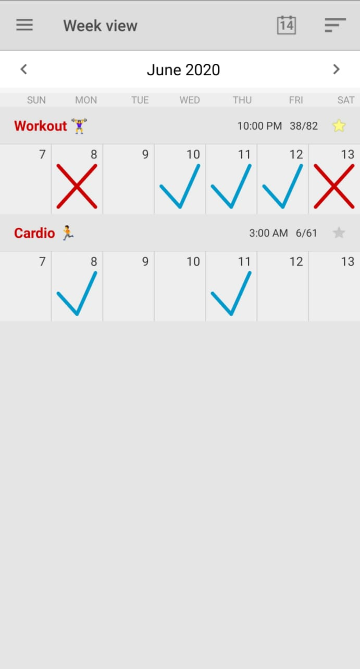

* You have to use Redux and React router.
* No need for user authentication.
* You can take inspiration from habit trackers just google them

**Points on which the project will be judged**

* All functionalities mentioned above
* ***VIDEO***
* HOST the project else your submission will be rejected!
* Github
  + Readme.md file ( a good readme should contain folder structure, how to start a project etc)
* Code and Structure
  + Comments
  + Structuring of files and folder
  + Indentation
  + Variables and functions naming
* Design
* Creativity